**Java SE 8 Programmer I, Exam Number- 1ZO-808**

**Round-37, Vendor Exam Quiz, Date- 19-05-2019**

**QUESTION NO: 1**

Given the following segment of code :



Which two statements, if either were true, would make the code compile?

**A.** Vehicleis an interface that is implemented by theMotorcycleclass.

**B.** VehicleandMotorcycleboth implement theTransportationinterface

**C.** Vehicleis a superclass ofMotorcycle.

**D.** Motorcycleis a superclass ofVehicle.

**E.** VehicleandMotorcycleboth extend the Transportation superclass.

**F.** Motorcycleis an interface that implements the Vehicleclass.

**Answer: C,E**

Correct Ans A C

**QUESTION NO: 2**

Given the code fragment:

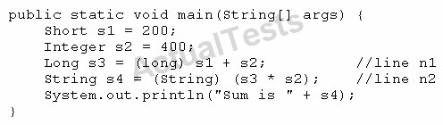

What is the result?

**A.** Sum is 600

**B.** Compilation fails at line n1.

**C.** Compilation fails at line n2.

**D.** A ClassCastException is thrown at line n1.

**E.** A ClassCastException is thrown at line n2.

**Answer: C**

**QUESTION NO: 3**

What is the name of the Java concept that uses access modifiers to protect variables and hide them within a class?

**A.** Encapsulation

**B.** Inheritance

**C.** Abstraction

**D.** Instantiation

**E.** Polymorphism

**Answer: A**

**Explanation:**

Using the private modifier is the main way that an object encapsulates itself and hidedata from the outside world.

**QUESTION NO: 4**

Given the following two classes:

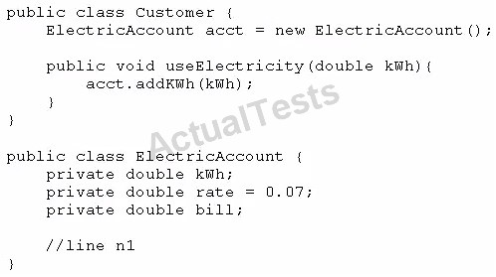

How should you write methods in the ElectricAccount class at line n1 so that the member variable bill is always equal to the value of the member variable kwh multiplied by the member variable rate?

Any amount of electricity used by a customer (represented by an instance of the customer class) must contribute to the customer's bill (represented by the member variable bill) through the method use Electricity method. An instance of the customer class should never be able to tamper with or decrease the value of the member variable bill.

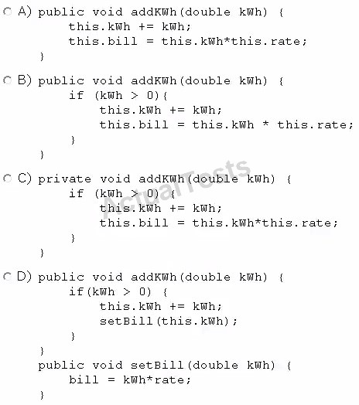

**A.** Option A

**B.** Option B

**C.** Option C

**D.** Option D

**Answer: B**

**QUESTION NO: 5** Given the code fragment:

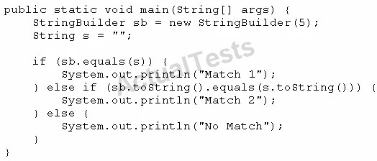

What is the result?

**A.** Match 1

**B.** Match 2

**C.** No Match

**D.** A NullPointerException is thrown at runtime.

**Answer: B**

**QUESTION NO: 6**

Given:

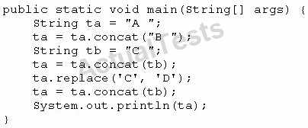

What is the result?

**A.** A B C D

**B.** A C D

**C.** A B C C

**D.** A B D

**E.** A B D C

**Answer: C**

**QUESTION NO: 7**

Given:

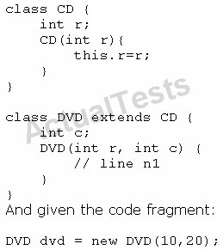

Which code fragment should you use at line n1 to instantiate the dvd object successfully?

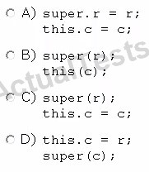

**A.** Option A

**B.** Option B

**C.** Option C

**D.** Option D

**Answer: C**

**QUESTION NO: 8**

Given the code fragment:

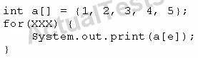

Which option can replace xxx to enable the code to print 135?

**A.**



**B.**



**C.**



**D.**



**Answer: B**

**QUESTION NO: 9**

Which statement best describes encapsulation?

**A.**

Encapsulation ensures that classes can bedesigned so that only certain fields and methods of an object are accessible from other objects.

**B.**

Encapsulation ensures that classes can be designed so that their methods are inheritable.

**C.**

Encapsulation ensures that classes can be designed with some fields and methods declared as abstract.

**D.**

Encapsulation ensures that classes can be designed so that if a method has an argument MyType x, any subclass of MyType can be passed to that method.

**Answer: A**

**QUESTION NO: 10**

Given the code fragment from three files:

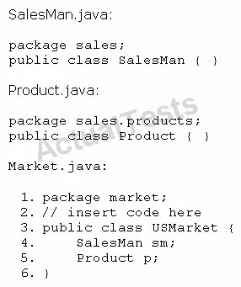

Which code fragment, when inserted at line 2, enables the code to compile?

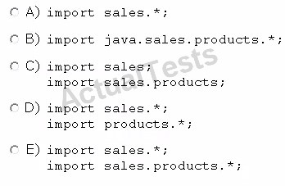

**A.** Option A

**B.** Option B

**C.** Option C

**D.** Option D

**E.** Option E

**Answer: E**

**QUESTION NO: 11**

Given the code fragment:

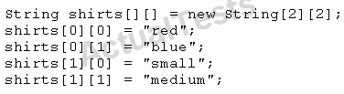

Which code fragment prints red: blue: small: medium?

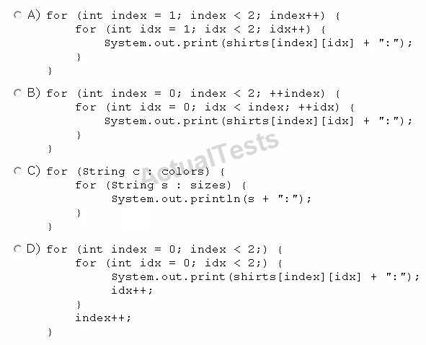

**A.** Option A

**B.** Option B

**C.** Option C

**D.** Option D

**Answer: D**

**QUESTION NO: 12**

Given the code fragment:

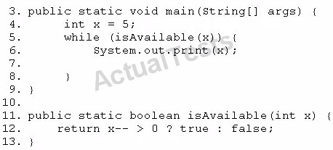

Which modification enables the code to print 54321?

**A.** Replace line 6 with System, out. print (--x) ;

**B.** At line 7, insert x --;

**C.** Replace line 6 with --x; and, at line 7, insert system, out. print (x);

**D.** Replace line 12 With return (x > 0) ? false: true;

Ans B **Answer: A**

**QUESTION NO: 13**

Given the code fragment:

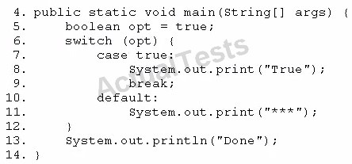

Which modification enables the code fragment to print TrueDone?

**A.** Replace line 5 With String opt = "true"; Replace line 7 with case "true":

**B.** Replace line 5 with boolean opt = l; Replace line 7 with case 1=

**C.** At line 9, remove the break statement.

**D.** Remove the default section.

**Answer: A**

**QUESTION NO: 14**

Given the following main method:

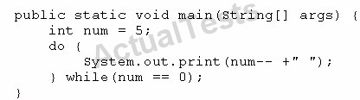

What is the result?

**A.** 5 4 3 2 1 0

**B.** 5 4 3 2 1

**C.** 4 2 1

**D.** 5

**E.** Nothing is printed

**Answer: D**

**QUESTION NO: 15**

Given the code fragment:

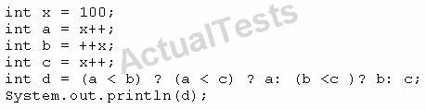

What is the result?

**A.** 100

**B.** 101

**C.** 102

**D.**103

**E.** Compilation fails **Answer: E**

**QUESTION NO: 16**

Given:

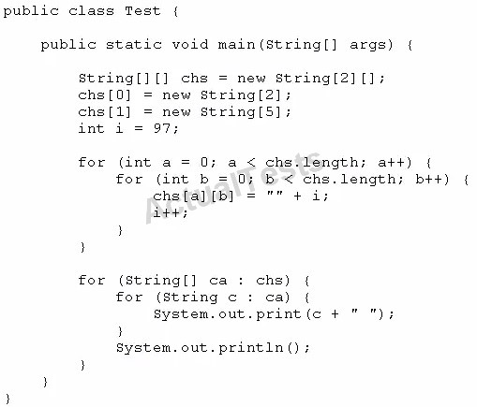

What is the result?

**A.**

97 98

99 100 null null null

**B.**

97 98

99 100 101 102 103

**C.** Compilation rails.

**D.** A NullPointerException is thrown at runtime.

**E.** An ArraylndexOutOfBoundsException is thrown at runtime.

**Answer: A**

**QUESTION NO: 17** Given the code fragment:

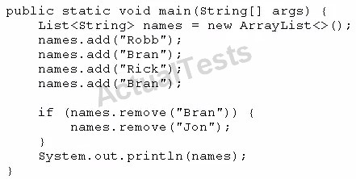

What is the result?

**A.** [Robb, Rick, Bran]

**B.** [Robb, Rick]

**C.** [Robb, Bran,Rick, Bran]

**D.** An exception is thrown at runtime.

**Answer: A**

**QUESTION NO: 18**

Given:

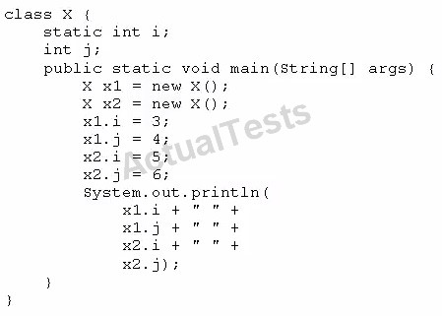

What is the result?

**A.** 3 4 5 6

**B.** 34 3 6

**C.** 5 4 5 6

**D.** 3 6 4 6

**Answer: C**

**QUESTION NO: 19**

Given the code fragment:

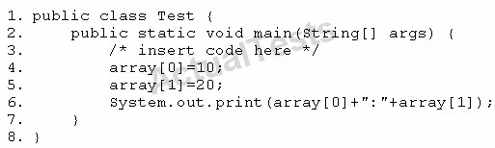

Which code fragment, when inserted at line 3, enables the code to print 10:20?

**A.** 

**B.**



**C.**



**D.**



**Answer: B**

**QUESTION NO: 20**

Which three are advantages of the Java exception mechanism?

**A.**

Improves the program structure because the error handling code is separated from the normal program function

**B.**

Provides a set of standard exceptions that covers all the possible errors

**C.**

Improves the program structure because the programmer can choose where to handle exceptions

**D.**

Improves the program structure because exceptions must be handled in the method in which they occurred

**E.**

Allows the creation of new exceptions that are tailored to the particular program being created

**Answer: A,C,D**

Ans A C E

**QUESTION NO: 21**

Given the code from the Greeting.Java file:

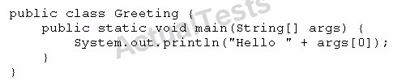

Which set of commands prints Hello Duke in the console?

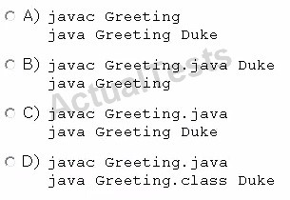

**A.** Option A

**B.** Option B

**C.** Option C

**D.** Option D

**Answer: C**

**QUESTION NO: 33**

Given the code fragment:

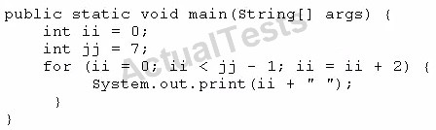

What is the result?

**A.** 2 4

**B.** 0 2 4 6

**C.** 0 24

**D.** Compilation fails

**Answer: C**

**QUESTION NO: 22**

Given the code fragment:

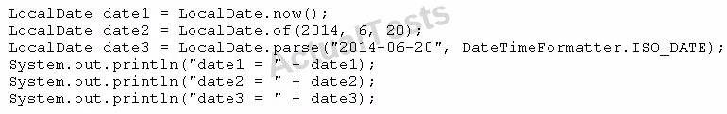

Assume that the system date is June 20, 2014. What is the result?

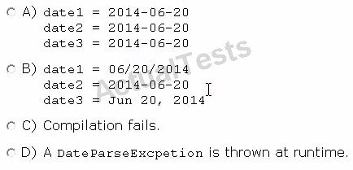

**A.** Option A

**B.** Option B

**C.** Option C

**D.** Option D

**Answer: A**

**QUESTION NO: 23**

Given the code fragment:

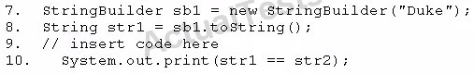

Which code fragment, when inserted at line 9, enables the code to print true?

**A.** String str2 = str1;

**B.** String str2 = new String (str1);

**C.** String str2 = sb1. toString ();

**D.** String str2 = "Duke";

**Answer: A**

**QUESTION NO: 24**

Given the code fragment:

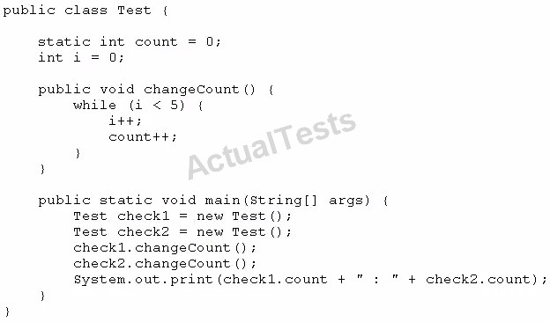

What is the result?

**A.** 10 : 10

**B.** 5 : 5

**C.** 5 : 10

**D.** Compilation fails

**Answer: A**

**QUESTION NO: 25**

Given:

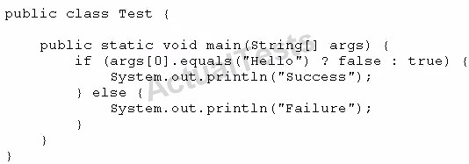

And given the commands:



What is the result?

**A.** Success

**B.** Failure

**C.** Compilation fails.

**D.** An exception is thrown at runtime **Answer: B**

**QUESTION NO: 26**

Which three statements describe the object-oriented features of the Java language?

**A.** Objects cannot be reused.

**B.** A subclass can inherit from a superclass.

**C.** Objects can share behaviors with other objects.

**D.** A package must contain more than one class.

**E.** Object is the root class of all other objects.

**F.** A main method must be declared in every class.

**Answer: B,C,F**

Ans B C E

**QUESTION NO: 27**

Given the following code:

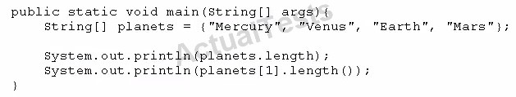

What is the output?

**A.** 4 4

**B.** 3 5

**C.** 4 7

**D.** 5 4

**E.** 4 5

**F.** 4 21

**Answer: E**

**QUESTION NO: 28**

You are developing a banking module. You have developed a class named ccMask that has a maskcc method.

Given the code fragment:

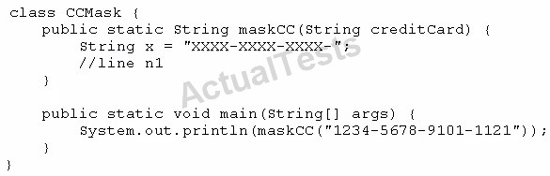

You must ensure that the maskcc method returns a string that hides all digits of the credit card number except the four last digits (and the hyphens that separate each group of four digits).

Which two code fragments should you use at line n1, independently, to achieve this requirement?

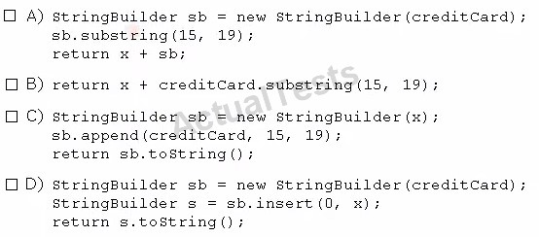

**A.** Option A

**B.** Option B

**C.** Option C

**D.** Option D

**Answer: B,C**

**QUESTION NO: 29**

Given:

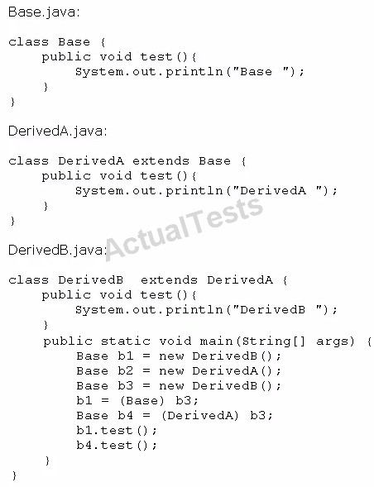

What is the result?

**A.** Base

DerivedA

**B.** Base

DerivedB

**C.** DerivedB

DerivedB

**D.** DerivedB

DerivedA

**E.** A classcast Exception is thrown at runtime.

**Answer: C**

**QUESTION NO: 30**

Given the code fragment:

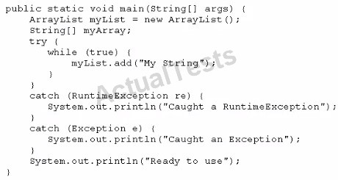

What is the result?

**A.**

Execution terminates in the firstcatch statement, and caught a RuntimeException is printed to the console.

**B.**

Execution terminates in the second catch statement, and caught an Exception is printed to the console.

**C.**

A runtime error is thrown in the thread "main".

**D.**

Execution completes normally, and Ready to use is printed to the console.

**E.**

The code fails to compile because a throws keyword is required.

**Answer: C**

**QUESTION NO: 31**

Given the code fragments:

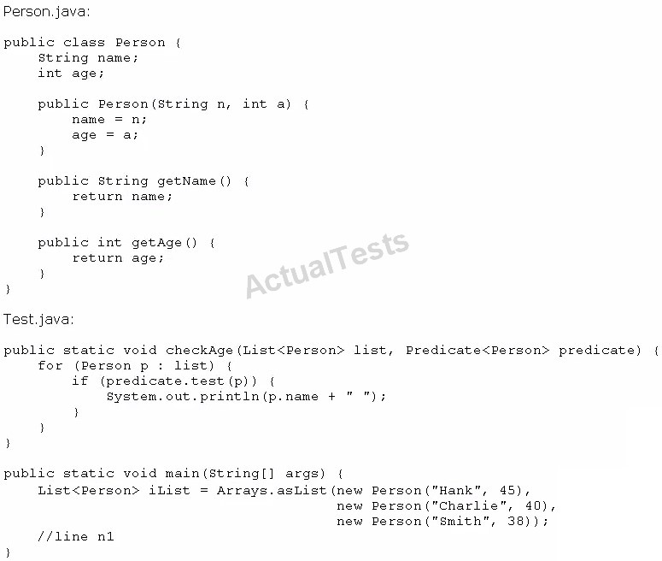

Which code fragment, when inserted at line n1, enables the code to print Hank?

**A.**



**B.** 

**C.**



**D.**



**Answer: C**

**QUESTION NO: 32**

Given the code fragment:

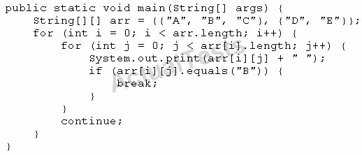

What is the result?

**A.** A B C

**B.** A B C D E

**C.** A B D E

**D.** Compilation fails.

**Answer: C**

**QUESTION NO: 33**

Given the code fragment:

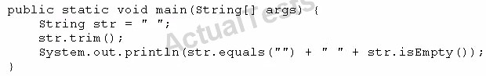

What is the result?

**A.** true true

**B.** true false

**C.** false false

**D.** false true

**Answer: C**

**QUESTION NO: 34**

Given the code fragment:

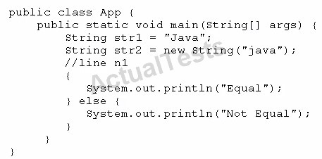

Which code fragment, when inserted at line n1, enables the App class to print Equal?

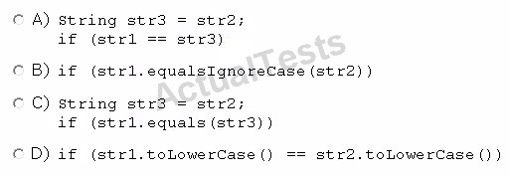

**A.** Option A

**B.** Option B

**C.** Option C

**D.** Option D

**Answer: B**

**QUESTION NO: 35**

Given:

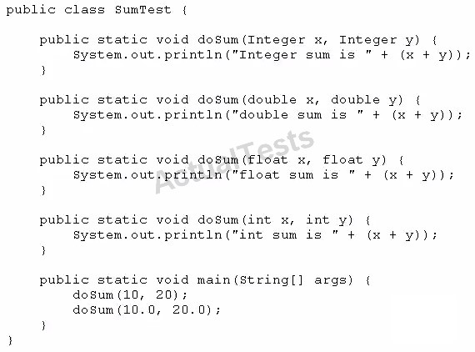

What is the result?

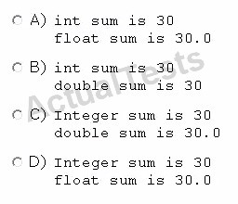

**A.** Option A

**B.** Option B

**C.** Option C

**D.** Option D

**Answer: B**

**QUESTION NO: 36**

Given the code fragment:

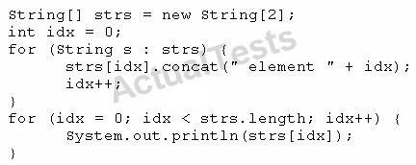

What is the result?

**A.** Element 0

Element 1

**B.** Null element 0

Null element 1

**C.** Null

Null

**D.** A NullPointerException is thrown at runtime.

**Answer: D**

**QUESTION NO: 37**

Given the code fragment:

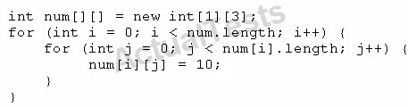

Which option represents the state of the num array after successful completion of the outer loop?

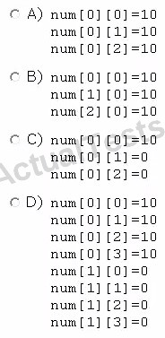

**A.** Option A

**B.** Option B

**C.** Option C

**D.** Option D

**Answer: A**

**QUESTION NO: 38**

You are asked to develop a program for a shopping application, and you are given the following information:

The applicationmust contain the classes Toy, EduToy, and ConsToy. The Toy class is the superclass of the other two classes.

The int calculatePrice (Toy t) method calculates the price of a toy.

The void printToy (Toy t) method prints the details of a toy.

Which definition of the Toy class adds a valid layer of abstraction to the class hierarchy?

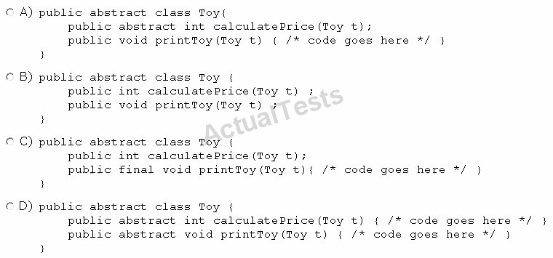

**A.** Option A

**B.** Option B

**C.** Option C

**D.** Option D

**Answer: A**

**QUESTION NO: 39**

Given the following code:

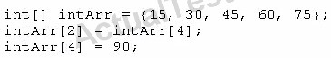

What are the values of each element in intArr after this code has executed?

**A.** 15, 60, 45, 90, 75

**B.** 15, 90, 45, 90, 75

**C.** 15, 30, 75, 60, 90

**D.** 15, 30, 90, 60, 90

**E.** 15, 4, 45, 60, 90

**Answer: C**

**QUESTION NO: 40**

Given the code fragment:



And given the requirements:

1. Process all the elements of the array in the order of entry.

1. Process all the elements of the array in the reverse order of entry.

1. Process alternating elements of the array in the order of entry.

Which two statements are true?

**A.** Requirements 1, 2, and 3 can be implemented by using the enhanced for loop.

**B.** Requirements 1, 2, and 3 can be implemented by using the standard for loop.

**C.** Requirements 2 and 3 CANNOT be implemented by using the standard for loop.

**D.** Requirement 1 can be implemented by using the enhanced for loop.

**E.** Requirement 3 CANNOT be implemented by using either the enhanced for loop or the standard for loop.

**Answer: D,E** Ans B D

**QUESTION NO: 41**

Given:

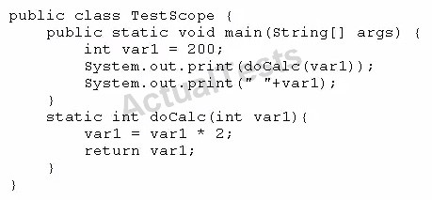

What is the result?

**A.** 400 200

**B.** 200 200

**C.** 400 400

**D.** Compilation fails.

**Answer: A**

**QUESTION NO: 42**

Given the following class declarations:

public abstract class Animal

public interface Hunter

public class Cat extends Animalimplements Hunter

public class Tiger extends Cat

Which answer fails to compile?

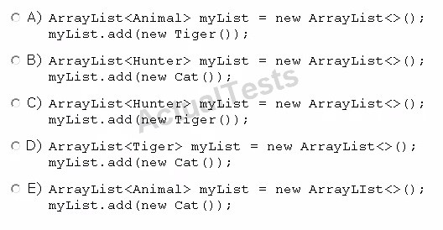

**A.** Option A

**B.** Option B

**C.** Option C

**D.** Option D

**E.** Option E

Answer: D

**Answer: E**

**QUESTION NO: 43**

Which statement is true about Java byte code?

**A.** It can run on any platform.

**B.** It can run on any platform only if it was compiled for that platform.

**C.** It can run on any platform that has the Java Runtime Environment.

**D.** It can run on any platform that has a Java compiler.

**E.** It can run on any platform only if that platform has both the Java Runtime Environment and a Java compiler.

**Answer: D**

Answer: C

Explanation:

Java bytecodes help make "write once, runanywhere" possible. You can compile your program into bytecodes on any platform that has a Java compiler. The bytecodes can then be run on any implementation of the Java VM. That means that as long as a computer has a Java VM, the same program written inthe Java programming language can run on Windows 2000, a Solaris workstation, or on an iMac.

**QUESTION NO: 44**

Given:

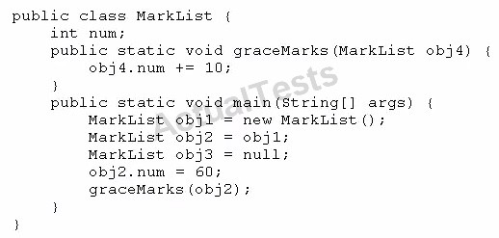

How many MarkList instances are created in memory at runtime?

**A.** 1

**B.** 2

**C.** 3

**D.** 4

**Answer: A**

**QUESTION NO: 46**

Given the code fragment:

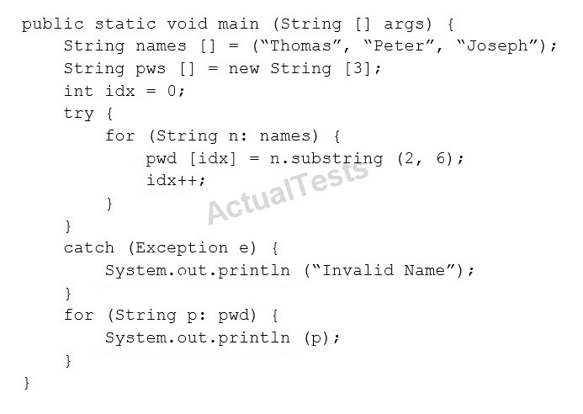

What is the result?

**A.** Invalid Name

**B.**



**C.**

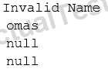

**D.**



**Answer: C**

**QUESTION NO: 47**

Given the code fragment:

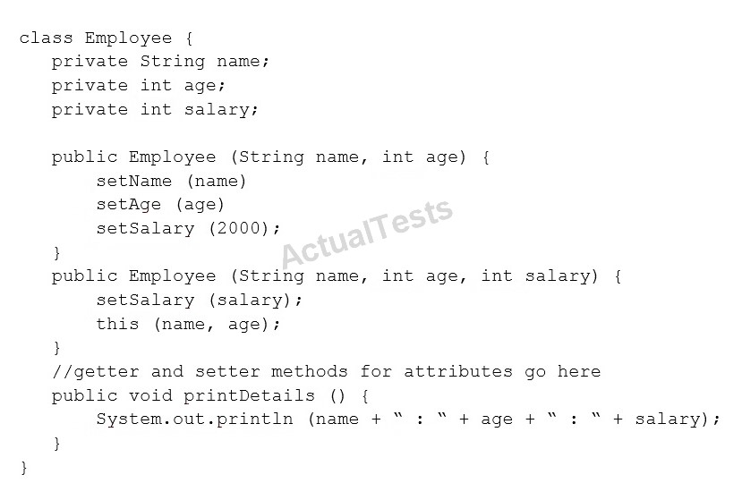

Test.java

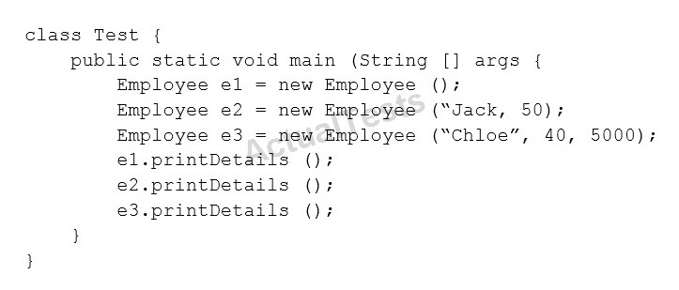

Which is the result?

**A.** Compilation fails in the Employee class.

**B.**

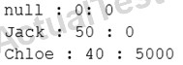

**C.**

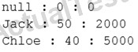

**D.** Compilation fails in the Test class.

**E.** Both the Employee class and the test class fail to compile.

**Answer: E**

**QUESTION NO: 48**

Given:

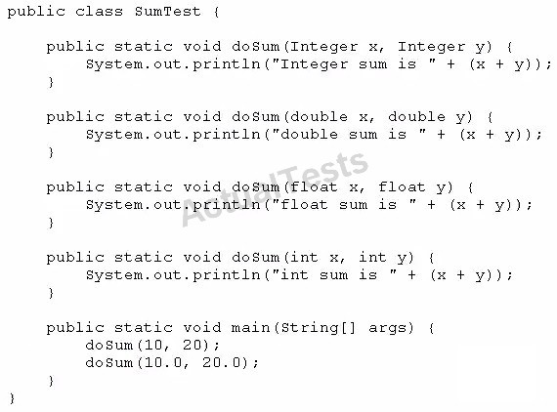

What is the result?

**A.**



**B.**



**C.**



**D.**



**Answer: D** Ans B

**QUESTION NO: 49**

Given the code fragment:

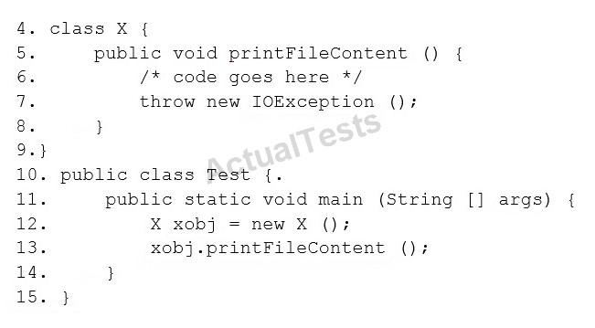

Which two modifications should you make so that the code compiles successfully?

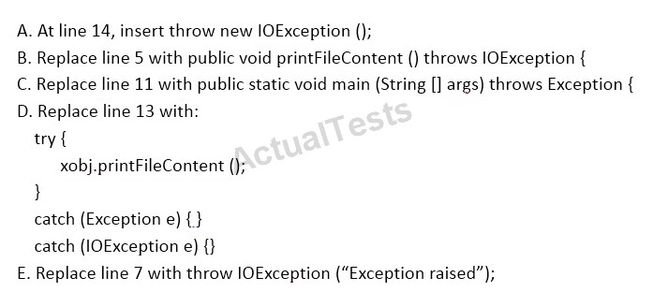

**A.** Option A

**B.** Option B

**C.** Option C

**D.** Option D

**E.** Option E

**Answer: E** Ans A C

**QUESTION NO: 50**

You are asked to create a method that accepts an array of integers and returns the highest value from that array.

Given the code fragment:

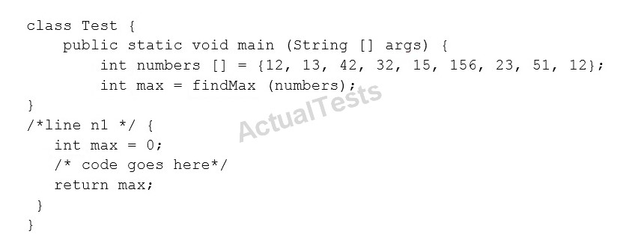

Which method signature do you use at line n1?

**A.** public int findMax (int [] numbers)

**B.** static int[] findMax (int max)

**C.** static int findMax (int [] numbers)

**D.** final int findMax (int [] )

**Answer: A** Ans C

**QUESTION NO: 51**

Which three statements are true about the structure of a Java class?

**A.** A public class must have a main method.

**B.** A class can have only one private constructor.

**C.** A method can have the same name as a field.

**D.** A class can have overloaded static methods.

**E.** The methods are mandatory componentsof a class.

**F.** The fields need not be initialized before use.

**Answer: A,C,E** Ans C D F

**QUESTION NO: 52**

Given the code fragment:

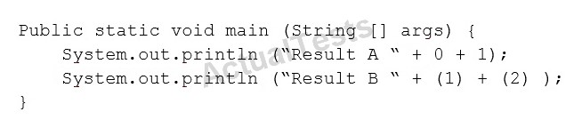

What is the result?

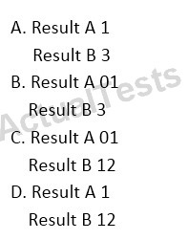

**A.** Option A

**B.** Option B

**C.** Option C

**D.** Option D

**Answer: C**

**QUESTION NO: 53**

Given:

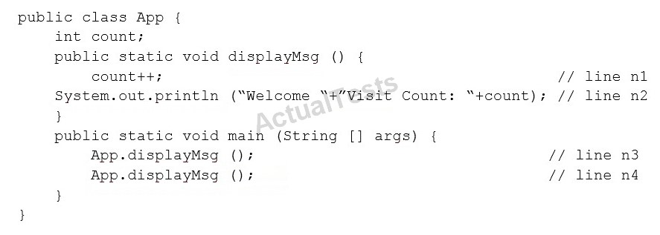

What is the result?

**A.** Compilation fails at line n3 and line n4.

**B.** Compilation fails at line n1 and line n2.

**C.** Welcome Visit Count:1

Welcome Visit Count: 2

**D.** Welcome Visit Count:1

Welcome Visit Count: 2

**Answer: B**

**QUESTION NO: 54**

Given the code fragment:

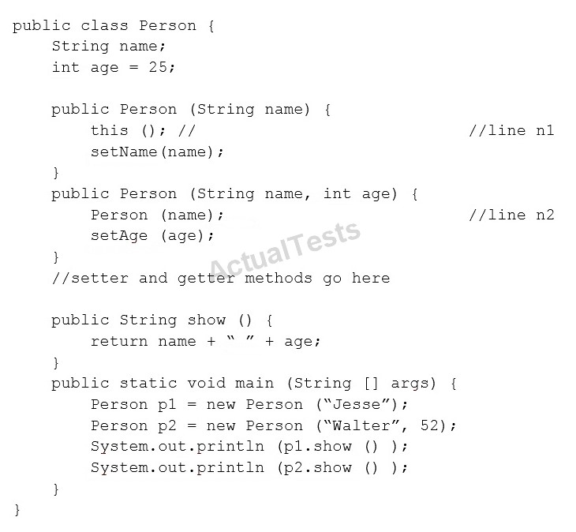

What is the result?

**A.** Compilation fails at both line n1 and line n2.

**B.** Compilation fails only at line n2.

**C.** Compilation fails only at line n1.

**D.** Jesse 25

Walter 52

**Answer: A**

**QUESTION NO: 55**

Which three statements are true about exception handling?

**A.** Only uncheckedexceptions can be rethrown.

**B.** All subclasses of the RuntimeException class are recoverable.

**C.** The parameter in a catch block is of Throwable type.

**D.** All subclasses of the RuntimeException class must be caught or declared to be thrown.

**E.** All subclassesof the Exception class except the RuntimeException class are checked exceptions.

**F.** All subclasses of the Error class are checked exceptions and are recoverable.

**Answer: C,E,F**

**QUESTION NO: 56**

Given the code fragment:

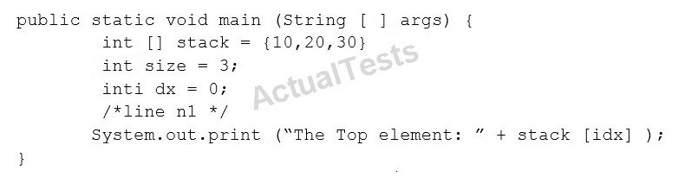

Which code fragment, inserted at line n1, pints The Top element: 30?

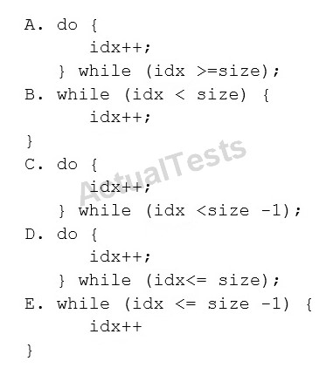

**A.** Option A

**B.** Option B

**C.** Option C

**D.** Option D

**E.** Option E

**Answer: A** Ans C

**QUESTION NO: 57**

Given the code fragment:

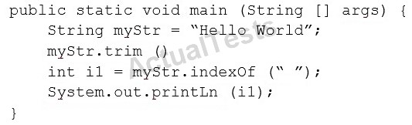

What is the result?

**A.** An exception is thrown at runtime.

**B.** -1

**C.** 5

**D.** 0

**Answer: A** Ans C

QUESTIONNO: 58

Given:

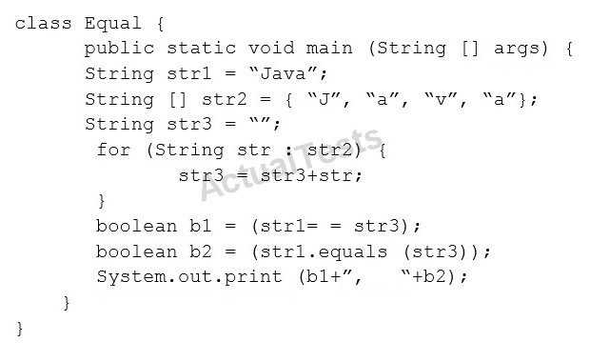

What is the result?

1. false, false
2. false, true
3. true, false
4. true, true

Answer: B

**QUESTION NO: 59**

Which two statements are true?

**A.** Error class is unextendable.

**B.** Error class is extendable.

**C.** Error is a RuntimeException.

**D.** Error is an Exception.

**E.** Error is a Throwable.

**Answer: B,C** Ans B E

**QUESTION NO: 60**

Given the code fragment:

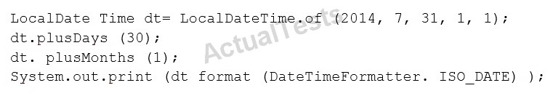

What is the result?

**A.** An exception is thrown at runtime.

**B.** 07-31-2014

**C.** 2014-07-31

**D.** 2014-09-30

**Answer: C**

**QUESTION NO: 61**

Given:

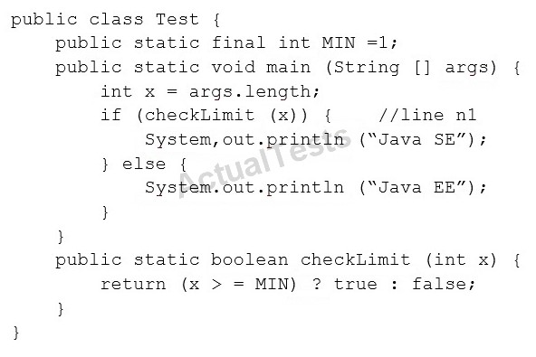

And given the commands:



What is the result?

**A.** Java SE

**B.** Java EE

**C.** Compilation fails at line n1.

**D.** ANullPointerException is thrown at runtime.

**Answer: B**

**QUESTION NO: 62**

Given the code fragments:

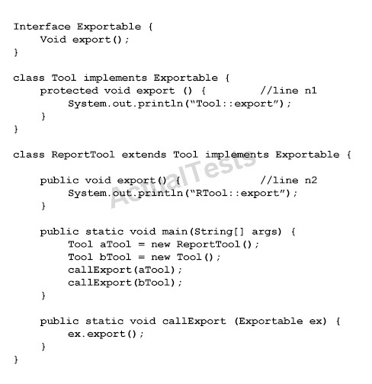

What is the result?

**A.** Compilation fails only at line n2.

**B.** RTool::export

Tool::export

**C.** Tool::export

Tool:export

**D.** Compilation fails only at line n1.

**E.** Compilationfails at both line n1 and line n2.

**Answer: E**

**QUESTION NO: 63**

Given the code fragment:

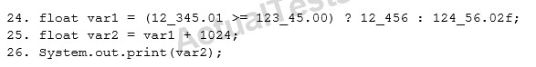

What is the result?

**A.** An exception is thrown at runtime.

**B.** Compilation fails.

**C.** 13480.0

**D.** 13480.02

**Answer: C**

**QUESTION NO: 64**

Given:

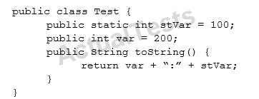

And given the code fragment:

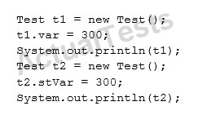

What is the result?

**A.** 300:300

200:300

**B.** 300:100

200:300

**C.** 300:0

0:300

**D.** 200:300

200:300

**Answer: D** Ans B

**QUESTION NO: 65**

Given:

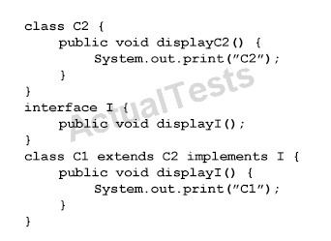

And given the code fragment:

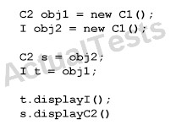

What is the result?

**A.** C2C2

**B.** C1C2

**C.** C1C1

**D.** Compilation fails

**Answer: A** Ans D

**QUESTION NO: 66**

Given the code fragments:

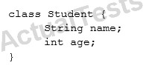

And,

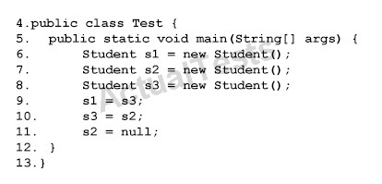

Which statement is true?

**A.** After line 11, three objects are eligible for garbage collection.

**B.** After line 11, two objects are eligible for garbage collection.

**C.** After line 11, one object is eligible for garbage collection.

**D.** After line 11, none of the objects are eligible for garbage collection.

**Answer: C**

**QUESTION NO: 67**

Given the code fragment:

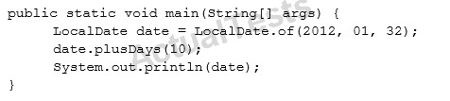

What is the result?

**A.** 2012-02-10

**B.** 2012-02-11

**C.** Compilation fails

**D.** A DateTimeException is thrown at runtime.

**Answer: D**

**Explanation:** java.time.DateTimeException: Invalid value for DayOfMonth (valid values 1 - 28/31): 32

**QUESTION NO: 68**

Given the following class:

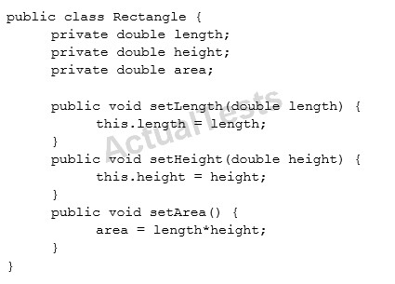

Which two changes would encapsulate this class and ensure that the area field is always equal to length * height whenever the Rectangle class is used?

**A.** Call the setArea method at the end of the setHeight method.

**B.** Call the setArea method at the beginning of the setHeight method.

**C.** Call the setArea method at the end of the setLength method.

**D.** Call the setArea method at the beginning of the setLength method.

**E.** Change the setArea method to private.

**F.** Change the area field to public.

**Answer: A,E** Ans A C

**QUESTION NO: 69**

Given the code fragment:

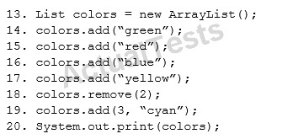

What is the result?

**A.** (green, red, yellow, cyan)

**B.** (green, blue, yellow, cyan)

**C.** (green, red, cyan, yellow)

**D.** AnIndexOutOfBoundsExceptionis thrown at runtime.

**Answer: C** Ans A

**QUESTION NO: 70**

Given the code fragment:

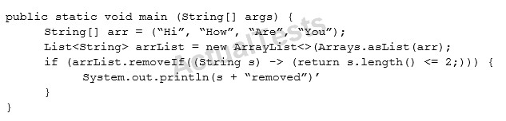

What is the result?

**A.** Compilation fails.

**B.** Hi removed

**C.** An UnsupportedOperationException is thrown at runtime.

**D.** The program compiles, but it prints nothing.

**Answer: A**